AmoCRM registration

Made on 08.10.2018.

To use the API of AmoCRM, you need to generate API credentials.

1. Go to the AmoCRM page https://www.amocrm.ru/, enter you data and click ‘Try it for free’.



1. Enter information about yourself and click ‘Start Now’.



1. When you have entered in your personal cabinet, please click ‘Settings’.

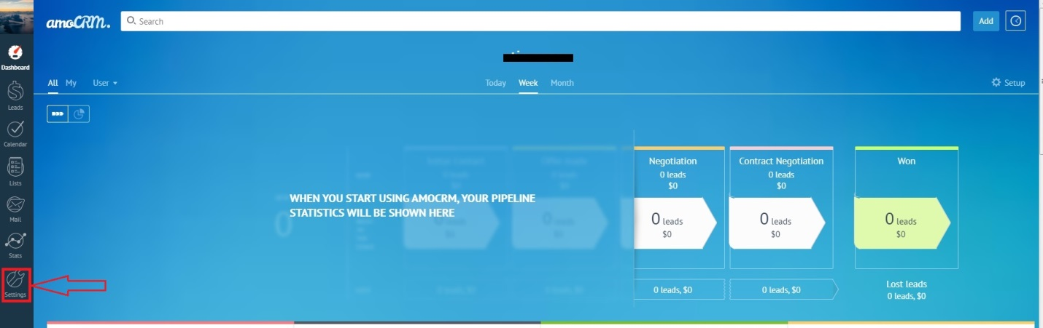

Your API credentials : subdomain – for additional data.

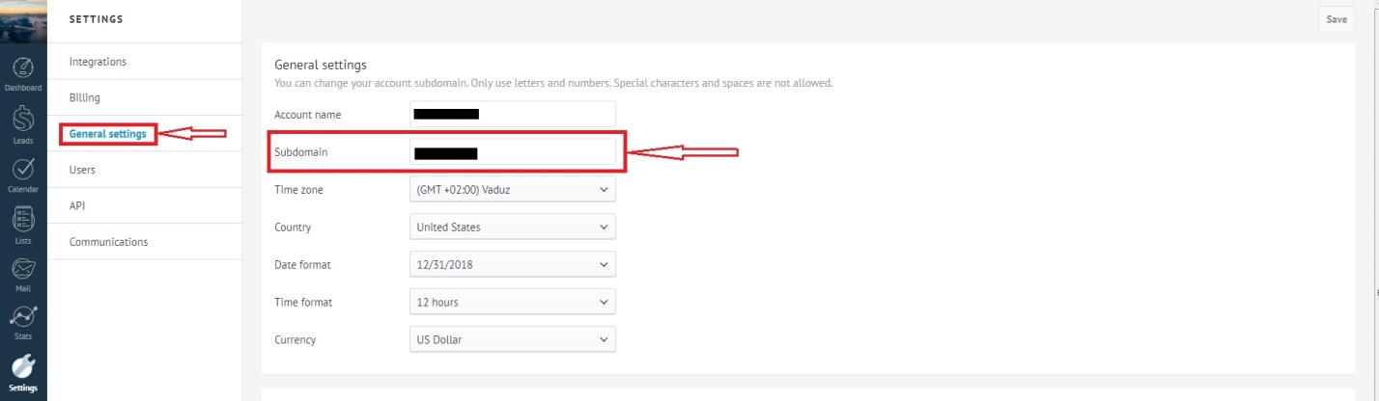

1. Your API credentials: e-mail – for client ID.

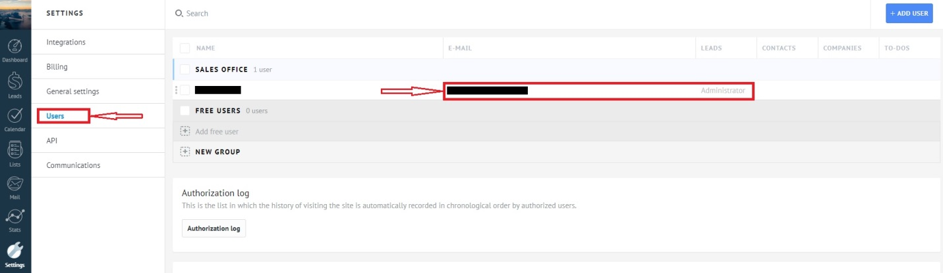

1. Your API credentials: API Key – for Client Secret.

